Placing Land Line Calls from Cellular Phones
Many cellular phones today are equipped with Wi-Fi transceivers and SIP phone clients. Cellular phones such as the Nokia N80 and N91, dual mode cellular phones, are gaining popularity, despite the easy-to-understand cold shoulder that this feature gets from the cellular providers.
Registration to an Internet Telephony Service Provider (ITSP) can allow the dual-mode cell phone owner to originate SIP calls from his home, office and many public Wi-Fi hot-spots. Although getting a SIP phone call is technically feasible, it is not quite practical as those calls cannot terminate successfully when the dual mode cell phone is out of the Wi-Fi Internet range.
Adding a Xorcom Asterisk® IP-PBX enhances the ways one can use his dual mode cellular phone substantially. For an organization equipped with Xorcom IP-PBX, the dual mode cellular phone will forward the employee’s extension to his cell phone; it will allow call initiation and reception as if the employee was sitting at his desk.
Without registration to any ITSP, the employee’s office telephony extension will follow him anywhere on the globe, providing the services and flexibility he is used to while maintaining low office extension local telephony costs.

Changing the Way People Use the Cellular Phones for Business
When using dual mode cellular phones, people use their comfortable cellular phone to initiate and accept telephone calls at the office. The Xorcom IP-PBX can be configured to forward the incoming call to the cellular phone when the cellular phone is out of the Wi-Fi IP network area.
Now people can be reached by using a single phone number. The phone will ring at the office and to the cellular phone (when registered to the Internet), otherwise it will forward the call to the cell phone through the cellular network.
In addition, if the employee has a laptop – he can install a soft phone on the laptop and get the calls to his computer.
Using the cellular phone everywhere and all the time is very comfortable, but there are three problems doing it:
- The user receives excessive radiation due to more calls that are done over his cell phone. In addition, the typical radiation level is high when the cell phone is used inside buildings, as the transmission passes through walls and ceilings and the cell phone adjusts itself to high transmission power. On the other hand, Wi-Fi transmission power is very low, and does not create health hazards to the user.
- In most places cellular calls are much more expensive than land lines calls. Even where cell phone calls are inexpensive, the described architecture will allow free “cellular” calls to the office even from places that charge excessive roaming charges (such as another country) as long as there is a Wi-Fi network in the neighborhood.
- When using the cellular phone, the user does not have an access to the corporate PBX, therefore, he cannot get PBX services, not even make a phone call to an internal extension.
The dual mode cell phone with the Xorcom IP-PBX provides the best solution for the corporate and the SMB market.

Xorcom Asterisk-based IP-PBX Product Lines
Xorcom offers three different Asterisk IP-PBX product lines that provide the advantages of the Asterisk IP-PBX ready-to-go server with high-quality telephony interfaces.
The low end XR1000 suits small and home office installations with support for FXS, FXO, and/or BRI interfaces. Up to 5 concurrent calls and 16 telephony ports are supported in the 19” 1U wall-or rack-mountable chassis. Click here for more information about the XR1000.
The more robust XR2000 and XR3000 both support combinations of FXS, FXO, BRI, E1 R2, T1 CAS and E1/T1 PRI. Both product lines are available in a standard 19” 2U rack-mountable chassis and support various Asterisk distributions, such as Elastix™ and trixbox CE®. RAID 1 is optional.
The XR2000 IP-PBX, optimized for SMB, supports up to 60 concurrent calls, up to 160 PSTN ports, and up to 300 users. Click here for more information about the XR2000.
The XR3000 IP-PBX is suited to enterprise-grade installations, and supports up to 300 concurrent calls, up to 670 PSTN ports, and up to 1000 users. Click here for more information about the XR3000.
Asterisk is a registered trademark of Digium, Inc. All other trademarks are the property of their respective owners.

Using the XR1000 to Support Dual Mode Cellular Phones
Figure 1: Sample SMB Organization Network with Internet and Wifi
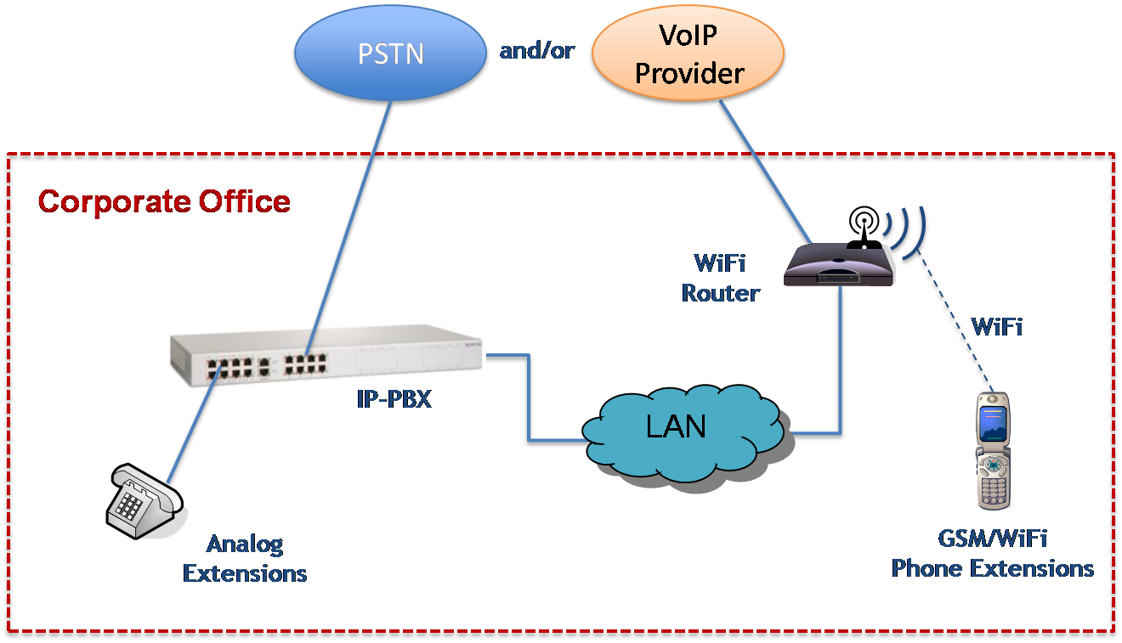
Figure 1 describes an organization with ADSL Internet access and a Wi-Fi router. The XR1000 is connected to the LAN. Cellular phones in the organization register to the XR1000.
Figure 2: Sample Office Connectivity
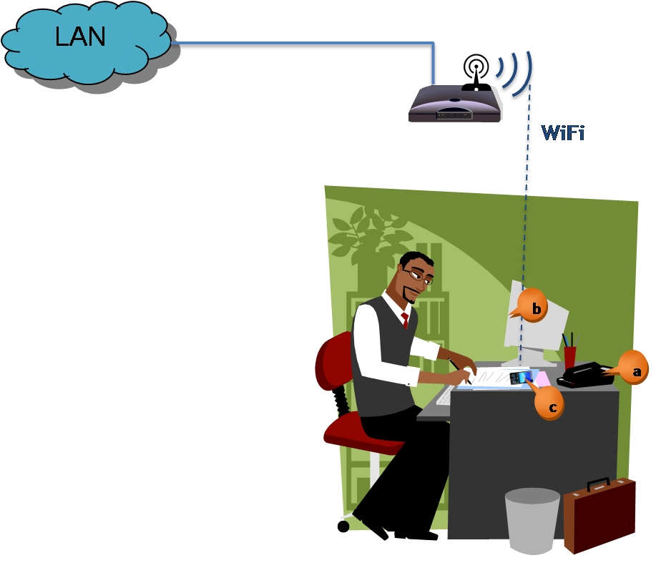
Figure 2 shows Joe Smith and his office. Joe gets all his incoming calls on his cell phone as well. When his extension (a) rings, so does his soft-phone (b) and his cellular phone (SIP/IAX client)(c).
Figure 3: Sample Hotel Connectivity
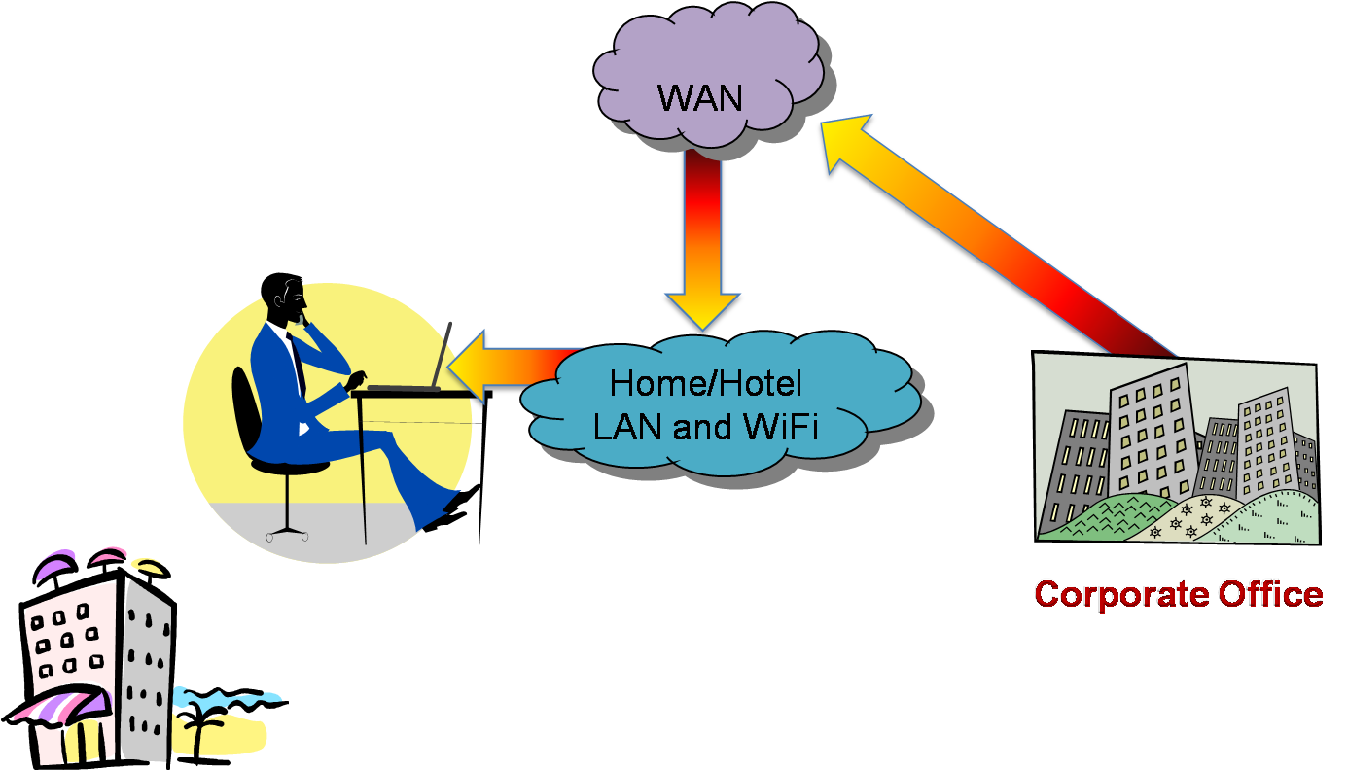
Figure 3 shows Joe at a hotel that has a wired LAN connection. His extension is now forwarded to his laptop.
Figure 4: Sample Internet Cafe Connectivity
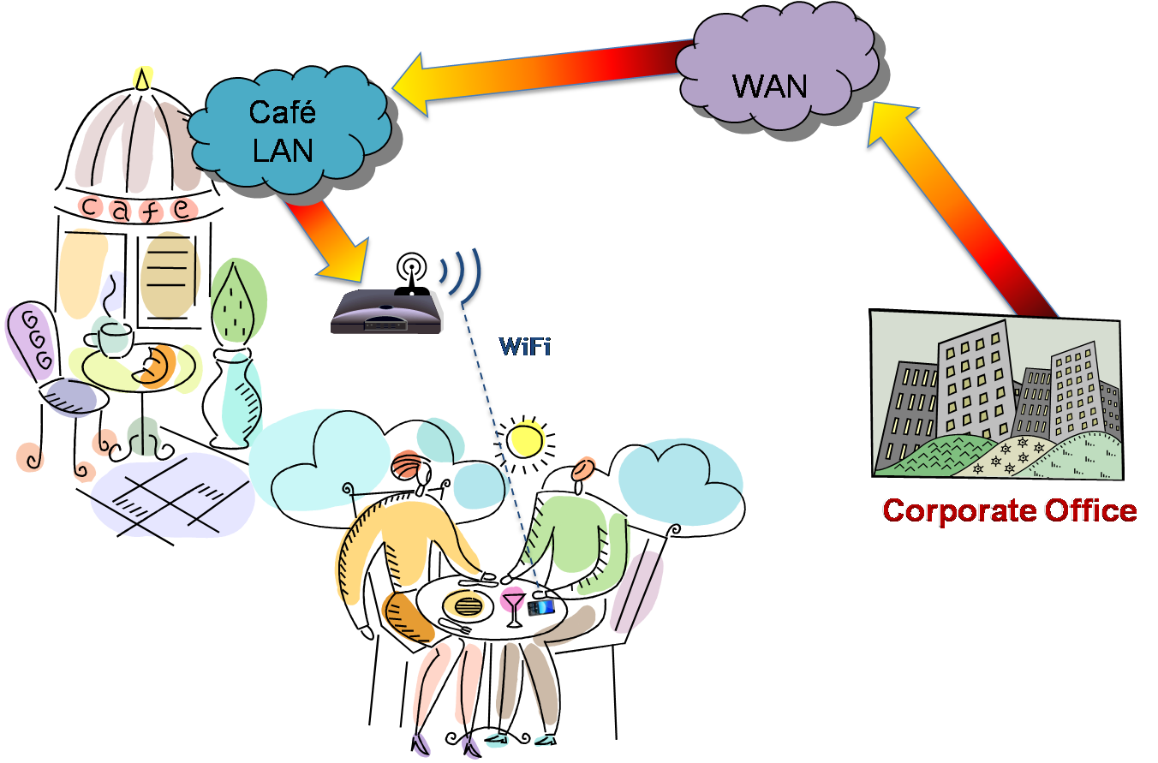
Figure 4 shows Joe at the cafe. He gets a phone call via Wi-Fi to his cell phone (the call was forwarded by the secretary to his office extension), makes free calls to his office and land-line calls to other phone numbers from his office.
Figure 5: Sample Street Connectivity
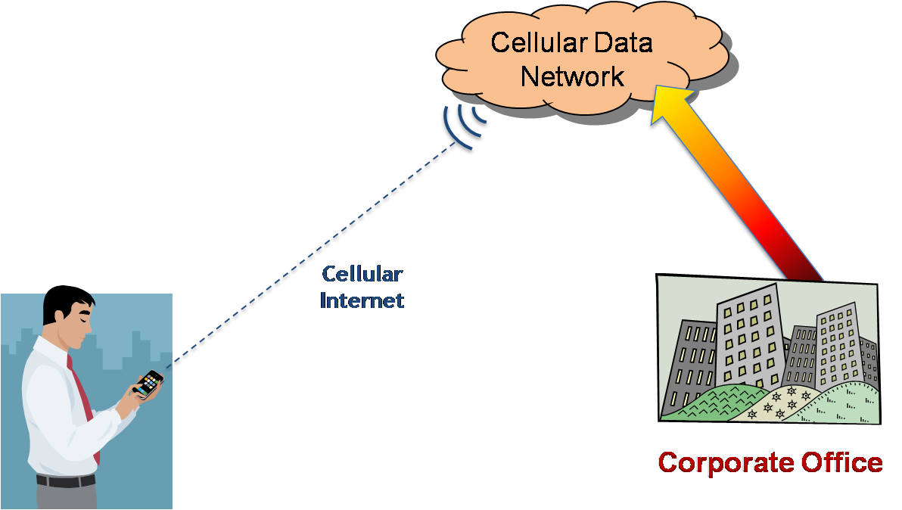
Figure 5 shows Joe out in the street. A call that was dialed to his office extension is routed by the Xorcom IP-PBX, which figures out that Joe’s cell phone is not in not registered as a SIP phone, to his cellular phone using the cellular network.
Figure 6: Sample SMB Connectivity
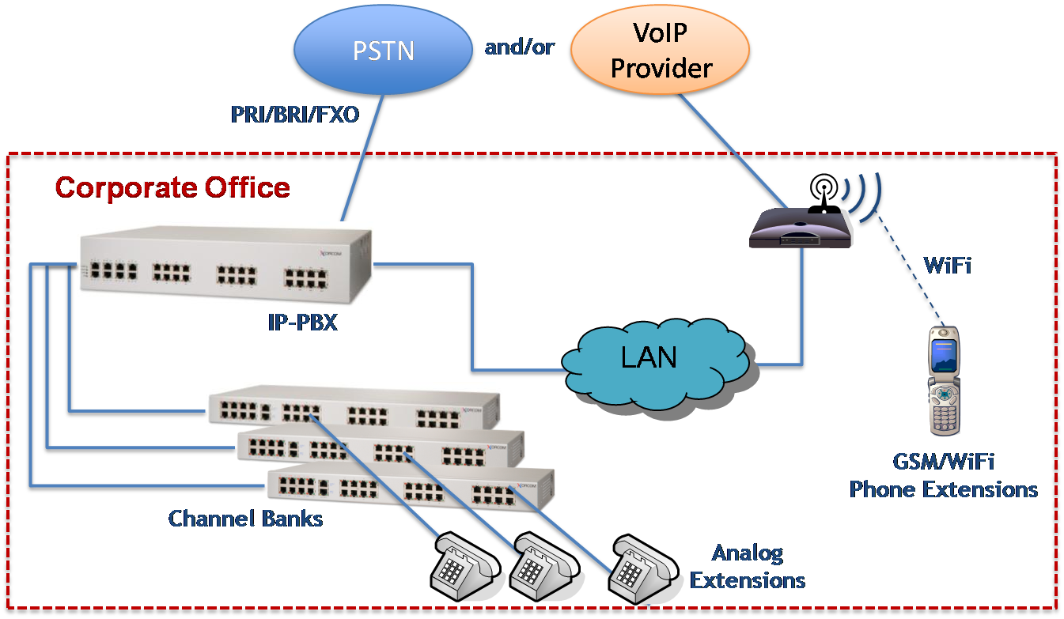
Figure 6 describes a larger organization using the XR2000. Joe will have the same cell phone benefits with this architecture as well.
For more information about this application and or Xorcom products in general, please contact us using the details below.

